ATM2004D SERIES --------------------- STANDARD CHARACTER LCD MODULES
* 5 x 8 with Cursor Dots * Transflective
* View Angle (6:00) * STN (Yellow green)
* 1/16 Duty, 1/5 Bias, 20CHAR x 4LINE * Controller/Driver (S6A0069 )
* LED Backlight (Yellow green) * Operating Temp (-20℃~70℃)
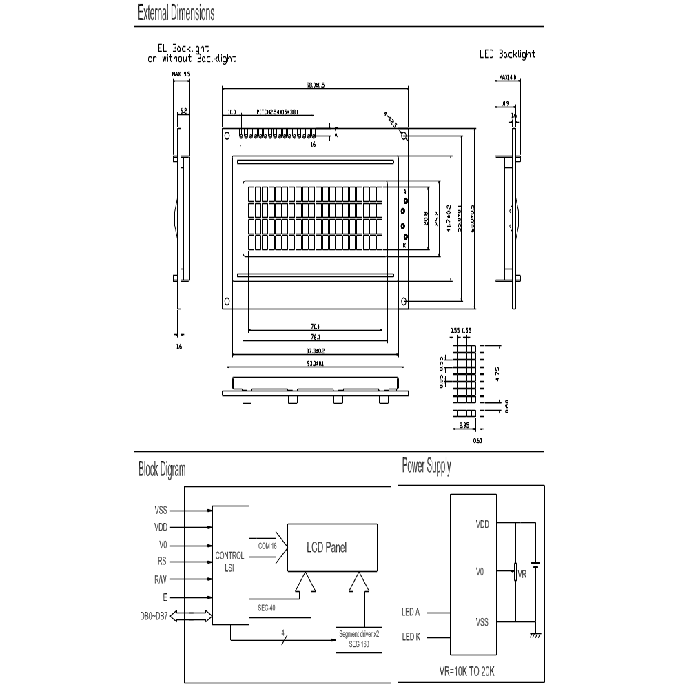
Mechanical Specifications Electrical Specifications
Item | Description(mm) |  | Item | symbol | min | typ | max | unit
Size | 98(L)x60(W)x14(H) |  | Supply Voltage for Logic | VDD | 4.5 | 5.0 | 5.5 | V
V.A | 76(L)x25.2(W) |  | Supply Voltage for LCD | VLCD | 4.0 | 4.5 | 5.0 | V
Character Pitch | 3.55 x 5.35 |  | Supply Current for Logic | IDD |  | 1.0 | 2.0 | mA
Dot Size | 0.55*0.55 |  | Supply Current for LED | IF |  |  | 80 | mA
Interface Signals---- J1
Pin | Symbol | level | Description | Pin | Symbol | level | Description
1 | Vss | 0V | Ground | 7~14 | DB0~DB7 | H/L | Data Bus Line
2 | Vdd | +5V | Supply Voltage for Logic | 15 | A | -- | Back Light anode:+4.2V
3 | V0 | -- | Operating Voltage for LCD | 16 | K | -- | Back Light cathode:0V
4 | R/S | H/L | H: Data  L: Instruction Code
5 | R/W | H/L | H: Data Read L: Data Write
6 | E | H,H-L | Enable Signal

